**INDIVIDUAL ASSIGNMENT**

**BANKING SYSTEM**

**Task 1: Database Design:**

1. Create the database named "HMBank"

* CREATE DATABASE HMBank;

1. Define the schema for the Customers, Accounts, and Transactions tables based on the provided schema.

* Customers Table

customer_id (Primary Key)

first_name

last_name

DOB

email

phone_number

address

Accounts Table

account_id (Primary Key)

customer_id (Foreign Key)

account_type

balance

Transactions Table

transaction_id (Primary Key)

account_id (Foreign Key)

transaction_type

amount

transaction_date

1. Create an ERD (Entity Relationship Diagram) for the database.

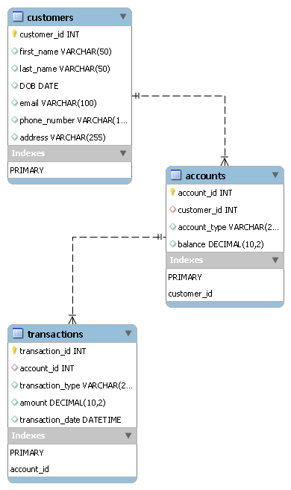

1. Create appropriate Primary Key and Foreign Key constraints for referential integrity.

Customers

customer_id is the Primary Key.

Accounts

account_id is the Primary Key.

customer_id is a Foreign Key referencing Customers(customer_id).

Transactions

transaction_id is the Primary Key.

account_id is a Foreign Key referencing Accounts(account_id).

1. Write SQL scripts to create the mentioned tables with appropriate data types, constraints, and relationships.

• Customers

• Accounts

• Transactions

Use HMBank;

CREATE TABLE Customers (

customer_id INT PRIMARY KEY AUTO_INCREMENT,

first_name VARCHAR (50) NOT NULL,

last_name VARCHAR (50) NOT NULL,

DOB DATE NOT NULL,

email VARCHAR (100),

phone_number VARCHAR (15) NOT NULL,

address VARCHAR (255)

);

CREATE TABLE Accounts (

account_id INT PRIMARY KEY AUTO_INCREMENT,

customer_id INT NOT NULL,

account_type VARCHAR (20) NOT NULL,

balance DECIMAL (10, 2) NOT NULL DEFAULT 0.00,

FOREIGN KEY (customer_id) REFERENCES Customers(customer_id)

);

CREATE TABLE Transactions (

transaction_id INT PRIMARY KEY AUTO_INCREMENT,

account_id INT NOT NULL,

transaction_type VARCHAR (20) NOT NULL,

amount DECIMAL (10, 2) NOT NULL,

transaction_date DATETIME NOT NULL,

FOREIGN KEY (account_id) REFERENCES Accounts(account_id)

);

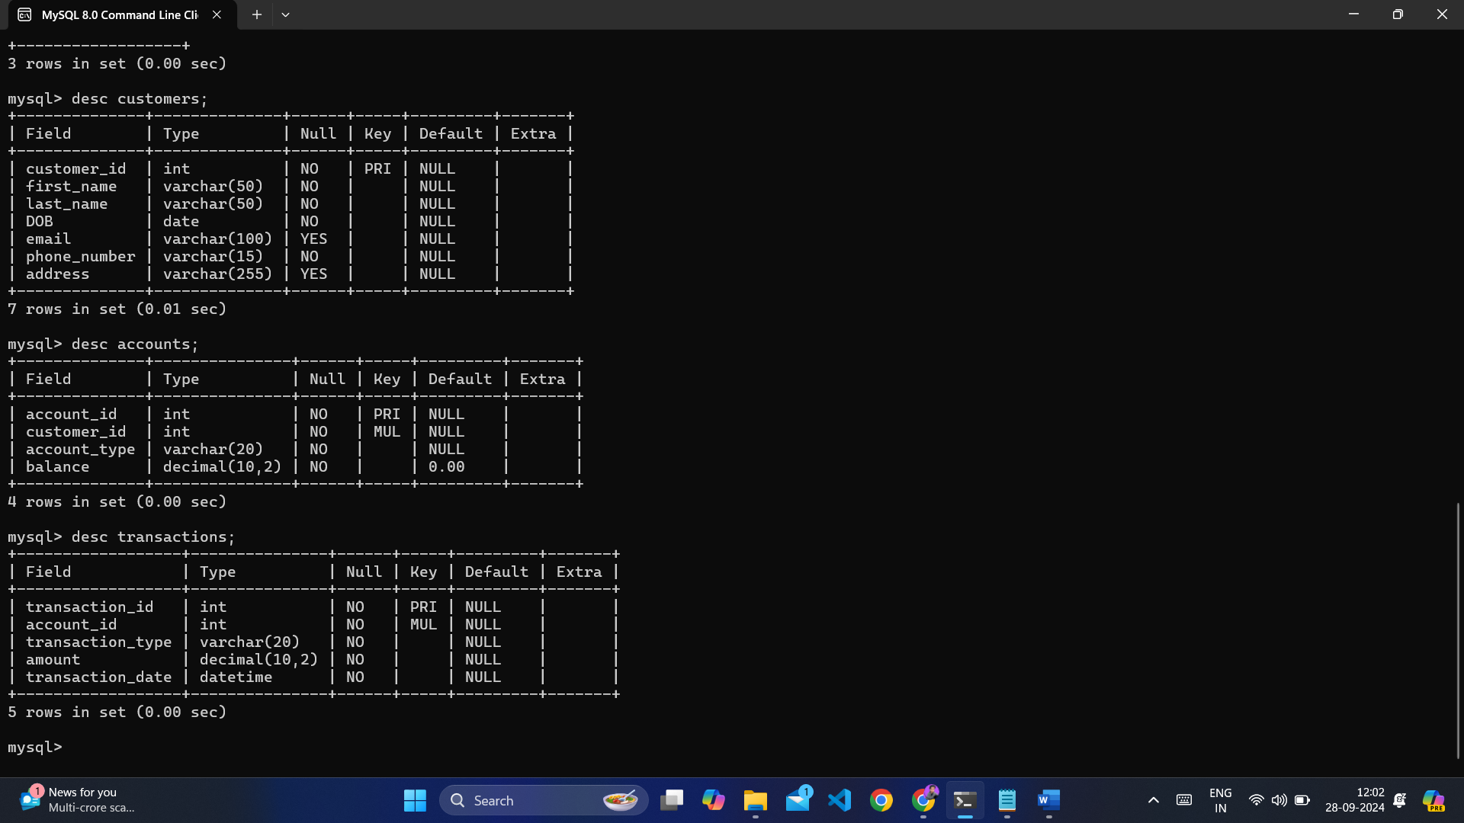

**Task 2: Select, Where, Between, AND, LIKE:**

1. Insert at least 10 sample records into each of the following tables.

• Customers

• Accounts

• Transactions

INSERT INTO Customers (customer_id, first_name, last_name, DOB, email, phone_number, address) VALUES

(1, 'Alzeb', 'Khan', '2001-06-24', 'alzebkhan@gmail.com', '9815515165', 'Jhansi'),

(2, 'Kartikey', 'Rajpoot', '2000-08-20', 'kartikey@gmail.com', '7054885265', 'Mumbai'),

(3, 'Aditya', 'Singh', '1999-12-05', 'aditya.singh@gmail.com', '9776543210', 'Bangalore'),

(4, 'Anaya', 'Kaur', '1980-02-15', 'anaya.kaur@gmail.com', '9765432109', 'Chennai'),

(5, 'Diya', 'Patel', '1995-03-25', 'diya.patel@gmail.com', '9654321098', 'Hyderabad'),

(6, 'Rohan', 'Mehta', '1988-07-10', 'rohan.mehta@gmail.com', '9543210987', 'Ahmedabad'),

(7, 'Sneha', 'Singh', '1992-11-30', 'sneha.singh@gmail.com', '9432109876', 'Pune'),

(8, 'Karan', 'Sharma', '1983-04-22', 'karan.sharma@gmail.com', '9321098765', 'Jaipur'),

(9, 'Pooja', 'Verma', '1999-01-01', 'pooja.verma@gmail.com', '9210987654', 'Lucknow'),

(10, 'Rahul', 'Chowdhary', '1996-09-12', 'rahul.chowdhary@gmail.com', '9109876543', 'Kolkata');

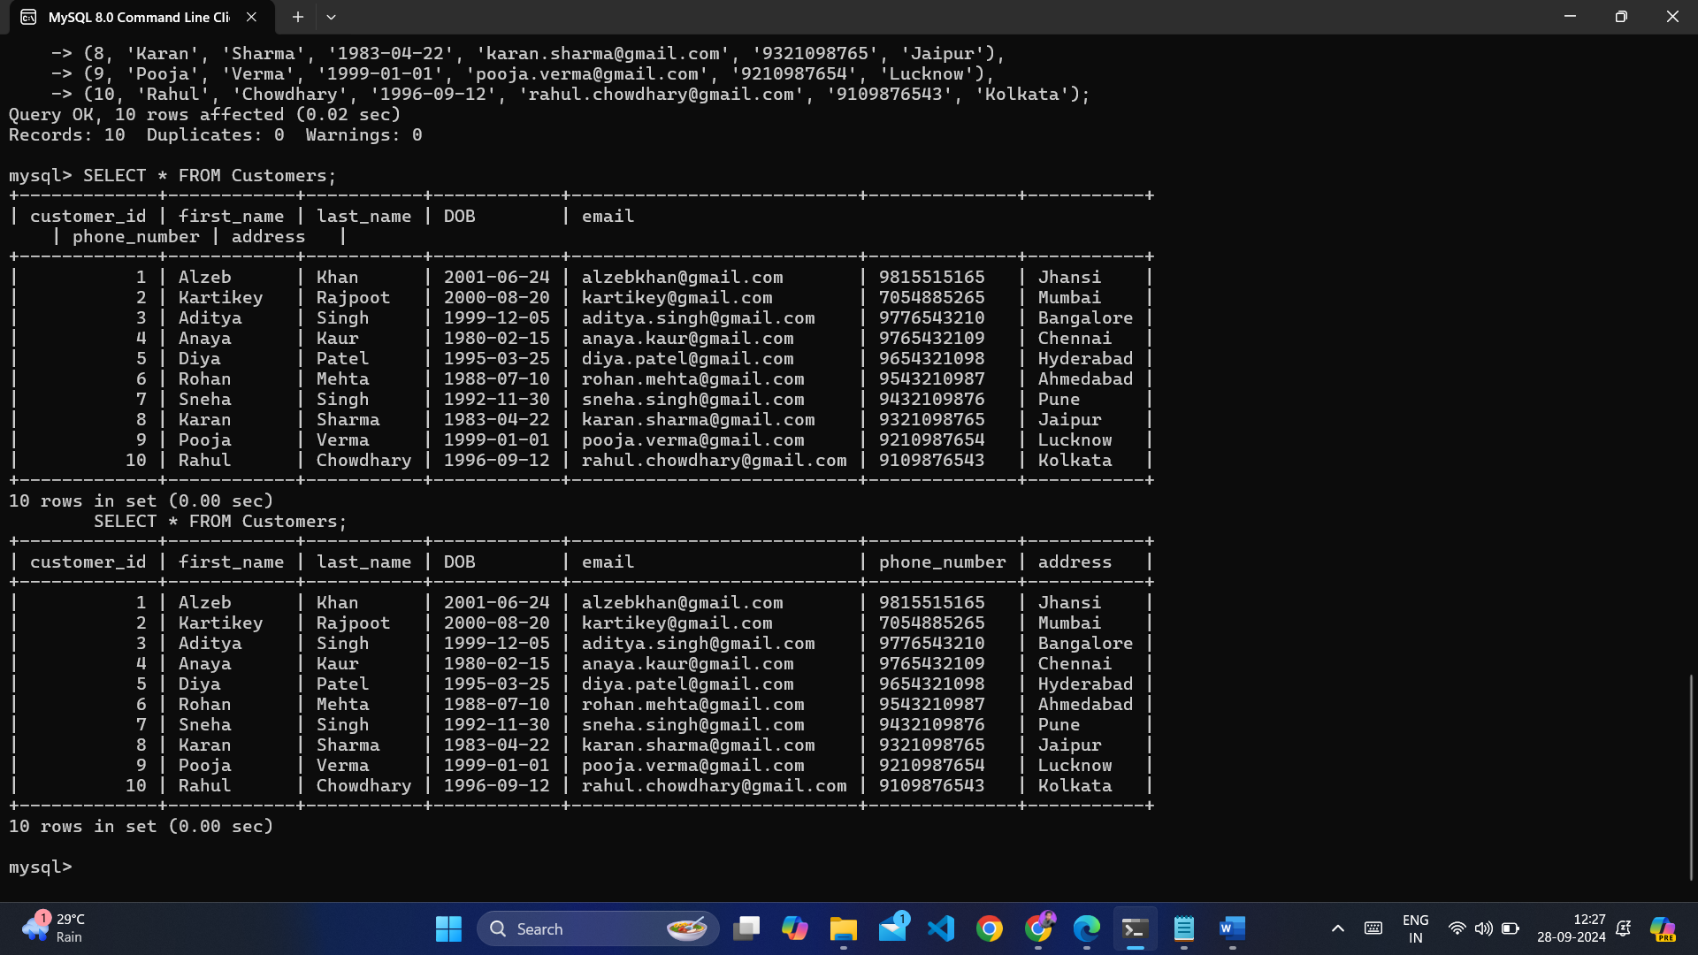

INSERT INTO Accounts (account_id, customer_id, account_type, balance) VALUES

(101, 1, 'savings', 1500.00),

(102, 2, 'current', 2500.00),

(103, 3, 'savings', 0.00),

(104, 4, 'zero_balance', 0.00),

(105, 5, 'savings', 300.00),

(106, 6, 'current', 1200.00),

(107, 7, 'savings', 800.00),

(108, 8, 'current', 1500.00),

(109, 9, 'savings', 500.00),

(110, 10, 'zero_balance', 0.00);

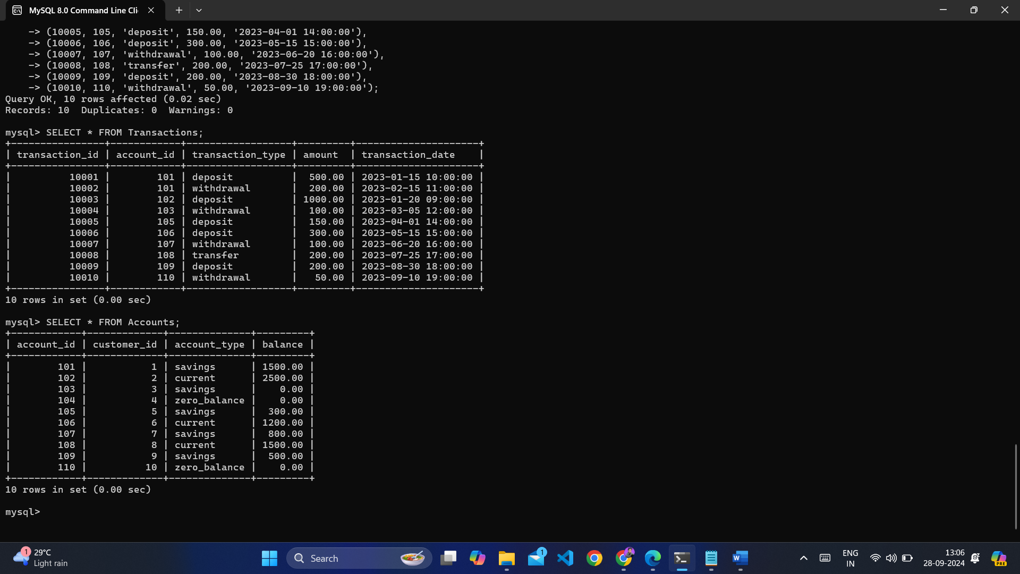

.

INSERT INTO Transactions (transaction_id, account_id, transaction_type, amount, transaction_date) VALUES

(10001, 101, 'deposit', 500.00, '2023-01-15 10:00:00'),

(10002, 101, 'withdrawal', 200.00, '2023-02-15 11:00:00'),

(10003, 102, 'deposit', 1000.00, '2023-01-20 09:00:00'),

(10004, 103, 'withdrawal', 100.00, '2023-03-05 12:00:00'),

(10005, 105, 'deposit', 150.00, '2023-04-01 14:00:00'),

(10006, 106, 'deposit', 300.00, '2023-05-15 15:00:00'),

(10007, 107, 'withdrawal', 100.00, '2023-06-20 16:00:00'),

(10008, 108, 'transfer', 200.00, '2023-07-25 17:00:00'),

(10009, 109, 'deposit', 200.00, '2023-08-30 18:00:00'),

(10010, 110, 'withdrawal', 50.00, '2023-09-10 19:00:00');

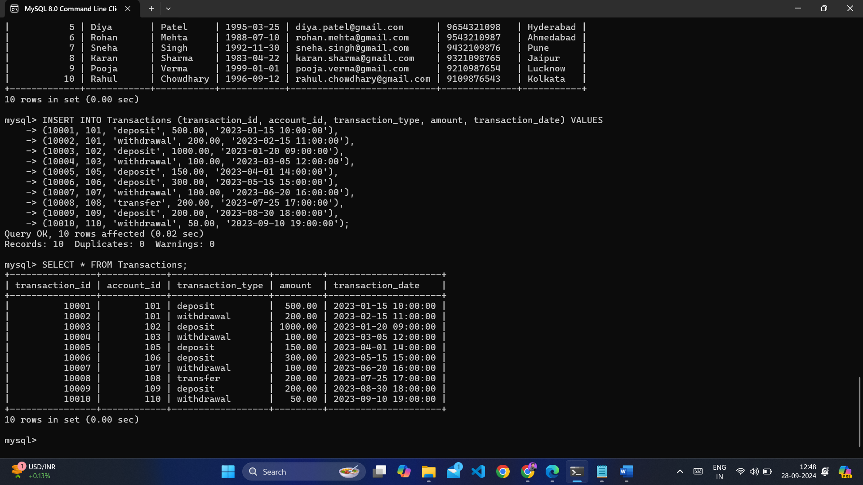

1. Write SQL queries for the following tasks:
2. Write a SQL query to retrieve the name, account type and email of all customers.

SELECT first_name, last_name, account_type, email

FROM Customers, Accounts

WHERE Customers.customer_id = Accounts.customer_id;

1. Write a SQL query to list all transaction corresponding customer.

SELECT first_name, last_name, transaction_type, amount, transaction_date

FROM Customers, Accounts, Transactions

WHERE Customers.customer_id = Accounts.customer_id

AND Accounts.account_id = Transactions.account_id;

1. Write a SQL query to increase the balance of a specific account by a certain amount.

UPDATE Accounts

SET balance = balance + 100.00

WHERE account_id = 101;

1. Write a SQL query to Combine first and last names of customers as a full_name.

SELECT CONCAT (first_name, ' ', last_name) AS full_name

FROM Customers;

1. Write a SQL query to remove accounts with a balance of zero where the account type is savings.

DELETE FROM Accounts

WHERE balance = 0 AND account_type = 'savings';

1. Write a SQL query to Find customers living in a specific city.

SELECT first_name, last_name, address FROM Customers

WHERE address LIKE '%Jhansi%';

1. Write a SQL query to Get the account balance for a specific account.

SELECT account_id, balance FROM Accounts

WHERE account_id = 101;

1. Write a SQL query to List all current accounts with a balance greater than $1,000.

SELECT * FROM Accounts

WHERE account_type = 'current' AND balance > 1000;

1. Write a SQL query to Retrieve all transactions for a specific account.

SELECT * FROM Transactions

WHERE account_id = 101;

1. Write a SQL query to Calculate the interest accrued on savings accounts based on a given interest rate.

SELECT account_id, (balance * 0.03) AS interest

FROM Accounts WHERE account_type = 'savings';

1. Write a SQL query to Identify accounts where the balance is less than a specified overdraft limit.

SELECT * FROM Accounts

WHERE balance < -100.00;

1. Write a SQL query to Find customers not living in a specific city.

SELECT * FROM Customers

WHERE address NOT LIKE '%Jhansi%';

**Task 3: Aggregate functions, Having, Order By, GroupBy and Joins:**

1. Write a SQL query to Find the average account balance for all customers.

SELECT AVG (balance) AS average_balance

FROM Accounts;

1. Write a SQL query to Retrieve the top 10 highest account balances.

SELECT account_id, balance FROM Accounts

ORDER BY balance DESC LIMIT 10;

1. Write a SQL query to Calculate Total Deposits for All Customers in specific date.

SELECT SUM (amount) AS total_deposits FROM Transactions

WHERE transaction_type = 'deposit' AND DATE (transaction_date) = '2023-01-15';

1. Write a SQL query to Find the Oldest and Newest Customers.

SELECT MIN(DOB) AS oldest_customer, MAX(DOB) AS newest_customer FROM Customers;

1. Write a SQL query to Retrieve transaction details along with the account type.

SELECT t.transaction_id, t.transaction_type, t.amount, t.transaction_date, a.account_type

FROM Transactions t

JOIN Accounts a ON t.account_id = a.account_id;

1. Write a SQL query to Get a list of customers along with their account details.

SELECT c.first_name, c.last_name, a.account_id, a.account_type, a.balance

FROM Customers c

JOIN Accounts a ON c.customer_id = a.customer_id;

1. Write a SQL query to Retrieve transaction details along with customer information for a specific account.

SELECT t.transaction_id, t.transaction_type, t.amount, t.transaction_date, c.first_name, c.last_name

FROM Transactions t

JOIN Accounts a ON t.account_id = a.account_id

JOIN Customers c ON a.customer_id = c.customer_id

WHERE a.account_id = 101;

1. Write a SQL query to Identify customers who have more than one account.

SELECT c.customer_id, c.first_name, c.last_name

FROM Customers c

JOIN Accounts a ON c.customer_id = a.customer_id

GROUP BY c.customer_id

HAVING COUNT(a.account_id) > 1;

1. Write a SQL query to Calculate the difference in transaction amounts between deposits and withdrawals.

SELECT

(SELECT SUM (amount) FROM Transactions WHERE transaction_type = 'deposit') -

(SELECT SUM (amount) FROM Transactions WHERE transaction_type = 'withdrawal') AS difference;

1. Write a SQL query to Calculate the average daily balance for each account over a specified period.

SELECT a.account_id, SUM(t.amount) / COUNT(DISTINCT t.transaction_date) AS avg_daily_balance

FROM Accounts a

JOIN Transactions t ON a.account_id = t.account_id

WHERE t.transaction_date BETWEEN '2023-01-01' AND '2023-12-31'

GROUP BY a.account_id;

1. Calculate the total balance for each account type.

SELECT account_type, SUM (balance) AS total_balance

FROM Accounts

GROUP BY account_type;

1. Identify accounts with the highest number of transactions order by descending order.

SELECT a.account_id, COUNT(t.transaction_id) AS transaction_count

FROM Accounts a

JOIN Transactions t ON a.account_id = t.account_id

GROUP BY a.account_id

ORDER BY transaction_count DESC;

1. List customers with high aggregate account balances, along with their account types.

SELECT c.customer_id, c.first_name, c.last_name, a.account_type, SUM(a.balance) AS total_balance

FROM Customers c

JOIN Accounts a ON c.customer_id = a.customer_id

GROUP BY c.customer_id, c.first_name, c.last_name, a.account_type

HAVING total_balance > 1000;

1. Identify and list duplicate transactions based on transaction amount, date, and account.

SELECT t.account_id, t.amount, t.transaction_date, COUNT(*) AS transaction_count

FROM Transactions t

GROUP BY t.account_id, t.amount, t.transaction_date

HAVING transaction_count > 1

ORDER BY t.account_id, t.transaction_date;

**Tasks 4: Subquery and its type:**

1. Retrieve the customer(s) with the highest account balance.

SELECT first_name, last_name

FROM Customers

WHERE customer_id IN ( SELECT customer FROM Accounts

WHERE balance = (SELECT MAX (balance) FROM Accounts)

);

1. Calculate the average account balance for customers who have more than one account.

SELECT AVG (balance) AS average_balance

FROM Accounts

WHERE customer_id IN (

SELECT customer_id

FROM Accounts

GROUP BY customer_id

HAVING COUNT (account_id) > 1

);

1. Retrieve accounts with transactions whose amounts exceed the average transaction amount.

SELECT account_id

FROM Transactions

WHERE amount > (SELECT AVG (amount) FROM Transactions);

1. Identify customers who have no recorded transactions.

SELECT first_name, last_name

FROM Customers

WHERE customer_id NOT IN (

SELECT DISTINCT customer_id

FROM Accounts a

JOIN Transactions t ON a.account_id = t.account_id

);

1. Calculate the total balance of accounts with no recorded transactions.

SELECT SUM(balance) AS total_balance

FROM Accounts

WHERE account_id NOT IN (

SELECT DISTINCT account_id

FROM Transactions

);

1. Retrieve transactions for accounts with the lowest balance.

SELECT transaction_id, account_id, amount

FROM Transactions

WHERE account_id IN (

SELECT account_id

FROM Accounts

WHERE balance = (SELECT MIN (balance) FROM Accounts)

);

1. Identify customers who have accounts of multiple types.

SELECT c.customer_id, c.first_name, c.last_name

FROM Customers c

JOIN Accounts a ON c.customer_id = a.customer_id

GROUP BY c.customer_id

HAVING COUNT (DISTINCT account_type) > 1;

1. Calculate the percentage of each account type out of the total number of accounts.

SELECT account_type,

COUNT (*) * 100.0 / (SELECT COUNT (*) FROM Accounts) AS percentage

FROM Accounts

GROUP BY account_type;

1. Retrieve all transactions for a customer with a given customer_id.

SELECT transaction_id, account_id, transaction_type, amount

FROM Transactions

WHERE account_id IN (

SELECT account_id

FROM Accounts

WHERE customer_id = 1

);

1. Calculate the total balance for each account type, including a subquery within the SELECT clause.

SELECT account_type,

SUM (balance) AS total_balance,

(SELECT SUM (balance) FROM Accounts) AS total_overall_balance

FROM Accounts

GROUP BY account_type;